

**FRIO COUNTY**

***Request for Proposal (RFP) for Administration/Professional Services***

*Proposed Contract Funding for the Resilient Communities Program Grant*

**LEGAL NOTICE**

Frio County is seeking to contract with a qualified Administration/Professional Services to administer the Resilient Communities Program Grant, through the Texas General Land Office (GLO). Proposal of services and a statement of qualifications can be submitted to the attention of Frio County Auditor’s Office at 500 E. San Antonio St. Ste. #3, Pearsall, TX 78061. Deadline to receive proposals in the County Auditor’s Office is **3:00 P.M., August 29, 2025.** Proposals received after the time indicated will be returned unopened. The County reserves the right to negotiate with any and all individuals or firms that submit proposals, as per the Texas Professional Services Procurement Act and the Uniform Grant and Contract Management Standards. Section 3 Residents and Business Concerns, Minority Business Enterprises, Small Business Enterprises, Women Business Enterprises, and Labor Surplus Area firms are encouraged to submit proposals. For more information, visit [https://www.co.frio.tx.us/](https://www.co.frio.tx.us/page/frio.BidNotices). Frio County is an Affirmative Action/Equal Opportunity Employer.

**INVITATION TO SUBMIT PROPOSALS**

The County of Frio is seeking proposals for application preparation and grant contract implementation services. These services are being solicited to assist the County of Frio in its application and administration of a contract, if awarded, from the Resilient Communities Program allocation, or until all funds allocated are expended, through the Texas General Land Office (GLO). The County of Frio will be applying for such funding to support the water system and water drainage improvements in the County of Frio.

The submission requirements for this proposal are also included on the attached Request for Proposal (RFP) form. Firms and/or individuals should have past experience with federally funded programs.

The submission deadline at is at **3:00 P.M., Friday, August 29, 2025**, to *Frio County c/o Crystal Marquez, Frio County Auditor, 500 E. San Antonio St., Ste # 3, Pearsall, Texas 78061. Responses are to be sealed with* ***“RFP/RFQ Resilient Communities Program (RCP)” clearly marked on the outside of the envelope or box***. Hours of operation in the Frio County Auditor’s Office are Monday through Friday 8:00 am-5:00 pm. Please submit 5 copies and a USB drive of your proposal of services.

Frio County reserves the right to negotiate with any and all individuals or firms that submit proposals, as per the Texas Professional Services Procurement Act and the Uniform Grant and Contract Management Standards.

Frio County is an Affirmative Action/Equal Opportunity Employer.

## **RFP FOR ADMINISTRATION/PROFESSIONAL SERVICES**

The County of Frio is seeking to enter into a services contract with a competent administration/management firm/professional service provider to assist the County in the overall management of its recent Resilient Communities Program Grant for Flood Damage & Land Use Plan & Prevention Ordinance Project. The following outlines the request for proposals.

I. Scope of Work ‑ The professional administration/management firm/consultant to be hired is to provide contract‑related management services to the County of Frio, including but not limited to the following areas:

* Project Management
* Financial Management
* Environmental Review
* Real Property Acquisition/ URA
* Construction Management (if applicable)
* Fair Housing/Equal Opportunity (if applicable)
* Housing rehabilitation/affordable housing (if applicable)
* Audit/Contract Close-out Assistance

Please specify actual tasks to be performed under each of these categories.

II. Statement of Qualifications ‑ The County is seeking to contract with a competent professional administration/management firm/consultant that has had experience in grants/contracts administration. Specifically, it is seeking those consultant(s) or firm(s) with the following qualifications:

* Related experience in managing federally‑funded local public works construction projects
* Related Experience / Background with specific project type
* Certified Administrator of Resilient Communities Program (RCP) by GLO
* Consultant/Firm is not debarred or suspended from the Excluded Parties List System (EPLS) in the System for Award Management (SAM) [www.Sam.gov](http://www.Sam.gov) .

As such, please provide within your proposal a list of referrals from past local government clients, as well as resumes of all employees who will or may be assigned to provide technical assistance to the County on this project if your firm is awarded this management services contract.

III. Proposed Cost of Services ‑ Please provide your cost proposal to accomplish the scope of work by category outlined above and for any additional activities required. The proposed budget must include all costs that are necessary to successfully complete this project. Please note that the County of Frio will not use lowest/best bid as the sole basis for entering into this contract.

## **RFP FOR ADMINISTRATION/PROFESSIONAL SERVICES**

(Continued)

IV. Evaluation Criteria ‑ the proposal received will be evaluated and ranked according to the following criteria:

|  |  |  |  |
| --- | --- | --- | --- |
|  | Criteria |  | Maximum  Points |
|  | Experience |  | 30 |
|  | Work Performance |  | 30 |
|  | Capacity to Perform |  | 20 |
|  | Proposed Cost |  | 20 |
|  |  |  |  |
|  | **Total** |  | 100 |

V. Deadline for Submission – Please submit 5 copies and a USB drive of your proposal of services. Responses are to be sealed **with “*RFP/RFQ Resilient Communities Program (RCP)*” clearly marked on the outside of the envelope or box** and addressed to:

Crystal Marquez

Frio County Auditor’s Office

500 E. San Antonio St. Ste. # 3

Pearsall, Texas 78061

Submittals for these services shall be received by Frio County Auditor’s Office no later than **3:00 pm CST on Friday, August 29, 2025**, which is at least ten (10) days after the initial newspaper publication and contact dates of RFP.

**DISCLAIMER: This sample draft document was developed for *Resilient Communities Program (RCP)”* grant projects and does not include all applicable provisions. This document has important legal consequences. Please consult with your legal counsel with respect to its completion or modification to insure that it is in compliance with any appropriate local, state and federal laws applicable.**

**ADMINISTRATION/PROFESSIONAL SERVICES**

**PART I**

**AGREEMENT**

THIS AGREEMENT, entered into this _____ day of __________________, by and between the COUNTY OF FRIO, hereinafter called the “County”, acting herein by _______________________ hereunto duly authorized, and _______________________________ hereinafter called "the Contractor”, acting herein by ______________________________.

WITNESSETH THAT:

WHEREAS, the County of Frio desires to [implement/construct/etc.] the following: water system improvements and water drainage under the general direction of the Resilient Communities Program (RCP) Program administered by the Texas General Land Office (GLO); and Whereas the County desires to engage_____________________________ to render certain [professional /administration] services in connection with this Resilient Communities Program (RCP)” Project, Contract Number ______________.

NOW THEREFORE, the parties do mutually agree as follows:

1. Scope of Services

The Contractor will perform the services set out in Part II, Scope of Services.

2. Time of Performance - The services of the Contractor shall commence on __________________________. In any event, all of the services required and performed hereunder shall be completed no later than ________________________.

3. Local Program Liaison - For purposes of this Contract, the County Judge or equivalent authorized person will serve as the Local Program Liaison and primary point of contact for the Contractor. All required progress reports and communication regarding the project shall be directed to this liaison and other local personnel as appropriate.

4. Access to Records - The U.S. Department of Housing and Urban Development (HUD), Inspectors General, the Comptroller General of the United States, the Texas General Land Office (GLO), and the County, or any of their authorized representatives, shall have access to any documents, papers, or other records of the Contractor which are pertinent to the Resilient Communities Program (RCP)award, in order to make audits, examinations, excerpts, and transcripts, and to closeout the County’s Resilient Communities Program (RCP)contract with GLO.

5. Retention of Records - The Contractor shall retain all required records for three years after the County makes its final payment and all pending matters are closed.

6. Compensation and Method of Payment - The maximum amount of compensation and reimbursement to be paid hereunder shall not exceed $_________________. Payment to the Contractor shall be based on satisfactory completion of identified milestones in Part III - Payment Schedule of this Agreement.

7. Indemnification – The Contractor shall comply with the requirements of all applicable laws, rules and regulations, and shall exonerate, indemnify, and hold harmless the County and its agency members from and against any and all claims, costs, suits, and damages, including attorneys’ fees, arising out of the Contractor’s performance or nonperformance of the activities, services or subject matter called for in this agreement or in connection with the management and administration of the Resilient Communities Program (RCP) contract, and shall assume full responsibility for payments of Federal, State and local taxes on contributions imposed or required under the Social Security, worker's compensation and income tax laws.

8. Miscellaneous Provisions

a. This Agreement shall be construed under and in accord with the laws of the State of Texas, and all obligations of the parties created hereunder are performable in Frio County, Texas.

b. This Agreement shall be binding upon and inure to the benefit of the parties hereto and their respective heirs, executors, administrators, legal representatives, successors and assigns where permitted by this Agreement.

c. In any case one or more of the provisions contained in this Agreement shall for any reason be held to be invalid, illegal or unenforceable in any respect, such invalidity, illegality, or unenforceability shall not affect any other provision thereof and this Agreement shall be construed as if such invalid, illegal, or unenforceable provision had never been contained herein.

d. If any action at law or in equity is necessary to enforce or interpret the terms of this Agreement, the prevailing party shall be entitled to reasonable attorney's fees, costs, and necessary disbursements in addition to any other relief to which such party may be entitled.

e. This Agreement may be amended by mutual agreement of the parties hereto and a writing to be attached to and incorporated into this Agreement.

9. Extent of Agreement

This Agreement, which includes Parts I-IV, [*and if applicable,* including the following exhibits/attachments: represents the entire and integrated agreement between the County and the Contractor and supersedes all prior negotiations, representations or agreements, either written or oral. This Agreement may be amended only by written instrument signed by authorized representatives of both County and Contractor.

IN WITNESSETH WHEREOF, the parties have executed this Agreement by causing the same to be signed on the day and year first above written.

BY:

Signature

Mario Martinez

Printed Name

Frio County Commissioner Pct. 2_

Title

BY:

Contractor’s Authorized Representative

Printed Name

Title

**PART II**

**SCOPE OF SERVICES**

The Contractor shall provide the following scope of services: (choose contracted services)

A. Project Management

1. Develop a recordkeeping system consistent with program guidelines, including the establishment of a filing system.
2. Maintenance of filing system.
3. Provide general advice and technical assistance to the County personnel on implementation of project and regulatory matters.
4. Assist in the procurement of professional consulting engineering services through the request for proposal process, if applicable, and as required by the Resilient Communities Program (RCP) regulations.
5. Furnish County with necessary forms and procedures required for implementation of project.
6. Assist the County in meeting all special condition requirements that may be stipulated in the contract between the County and GLO.
7. Prepare and submit to GLO documentation necessary for amending the Resilient Communities Program (RCP) contract.
8. Conduct re-assessment of environmental clearance for any program amendments.
9. Prepare and submit quarterly reports (progress and minority hiring).
10. Prepare Financial Information Report or County.
11. Establish procedures to document expenditures associated with local administration of the project.
12. Provide guidance and assistance to County regarding acquisition of property:
13. Submit required reports concerning acquisition activities to GLO;
14. Establish a separate acquisition file for each parcel of real property acquired;
15. Determine necessary method(s) for acquiring real property;
16. Prepare correspondence to the property owners for the County’s signature to acquire the property or to secure an easement; and
17. Assist the County in negotiation with property owner(s).
18. Maintain Resilient Communities Program (RCP) Property Management register for any property/equipment purchased or leased.
19. Serve as liaison for the County during any monitoring visit by staff representatives from either GLO or the U.S. Department of Housing and Urban Development (HUD).

B. Financial Management

1. Assist the County in proving its ability to manage the grant funds to the state's audit division.
2. Assist the County in establishing and maintaining a bank account (Direct Deposit account) and/or separate local bank account, journals and ledgers.
3. Assist the County in submitting the required Accounting System Certification letter, Direct Deposit Authorization Form (if applicable), and/or Depository/Authorized Signatory form to GLO.
4. Prepare all fund drawdowns on behalf of the County in order to ensure orderly, timely payments to all contracting parties within the allotted time period.
5. Review invoices received for payment and file back-up documentation.
6. Provide general advice and technical assistance to County personnel on implementation of project and regulatory matters.
7. Assist the County in establishing procedures to handle the use of any Resilient Communities Program (RCP) program income.

C. Environmental Review

1. Prepare environmental assessment.
2. Coordinate environmental clearance procedures with other federal or state agencies and interested parties responsible for implementing applicable laws.
3. Document consideration of any public comments.
4. Prepare any required re-assessment of environmental assessment.
5. Prepare Request for Release of Funds and certifications to be sent to GLO.

D. Acquisition

1. Prepare required acquisition reports(s).
2. Obtain documentation of ownership for County-owned property and/or Right of Way (ROWs).
3. Maintain a separate file for each parcel of real property acquired.
4. Determine necessary method(s) for acquiring real property.
5. Prepare correspondence with property owners.
6. Assist County in negotiations with property owner(s).
7. Prepare required acquisition reports and submit to GLO.

E. Construction Management

1. Establish procedures to document expenditures associated with local construction of the project (if force account is applicable).
2. Assist County in determining whether and/or what Resilient Communities Program (RCP) contract activities will be carried out in whole or in part via force account labor.
3. Assist County in determining whether or not it will be necessary to hire temporary employees to specifically carry out Resilient Communities Program (RCP) contract activities.
4. Assist County in maintaining adequate documentation of personnel, equipment and materials expended/used and their costs.
5. Assist County in documenting compliance with all federal and state requirements related to equal employment opportunity.
6. Assist County in documenting compliance with all federal and state requirements related to minimum wage and overtime pay requirements.
7. Provide assistance to or act as local labor standards officer. Notify GLO in writing of name, address, and phone number of appointed labor standards compliance officer.
8. Request wage rates from GLO.
9. Provide sample Resilient Communities Program (RCP) contract documents to engineer.
10. Advertise for bids.
11. Make ten-day call to GLO.
12. Verify construction contractor eligibility with GLO.
13. Review construction contract.
14. Conduct pre-construction conference and prepare minutes.
15. Submit any reports of additional classification and rates to GLO.
16. Issue Notice of Start of Construction to GLO.
17. Review weekly payrolls, including compliance follow-ups. Conduct employee interviews.
18. Process change orders approved by County and the project engineer and submit to GLO prior to execution with the construction contractor.
19. Obtain Certificate of Construction Completion/Final Wage Compliance Report and submit to GLO.
20. Provide general advice and technical assistance to County personnel on implementation of project and regulatory matters.

F. Fair Housing / Equal Opportunity

1. Assist the County in developing, implementing and documenting new activities to affirmatively further fair housing during the contract period.
2. Maintain documentation of all project beneficiaries by ethnicity and gender.
3. Assist with the development and administration of the Citizen Participation Plan per 24 CFR Part 91, including grievance procedures.
4. Assist with Section 3 requirements per 24 CFR Part 135.
5. Prepare all Section 504 requirements per 24 CFR Part 8.
6. Provide all applicable equal opportunity provisions and certifications for inclusion in bid packet.
7. Ensure adoption of Excessive Force provision per 24 CFR Part 91.
8. Ensure the adequate publication of required notices.

G. Relocation

1. Prepare and submit local relocation guidelines to GLO for approval.
2. Assist County in identifying individuals to be relocated and prepare appropriate notices.
3. Interview relocatees and identify assistance needs.
4. Maintain a relocation record for each individual/family.
5. Provide education/assistance to relocatees.
6. Inventory local available housing resources and maintain a referral list.
7. Issue appropriate notices to relocatees.
8. Ensure that all payments are made in a timely manner.

H. Rehabilitation of Private Property

1. Prepare and submit local rehabilitation guidelines to GLO for approval.
2. Assist County in establishing escrow account and obtaining GLO approval.
3. Develop outreach and necessary application processing/verification forms.
4. Screen applicants.
5. Prepare work write-ups and cost estimates.
6. Issue Notice to Proceed to construction contractor(s).
7. Conduct interim/final inspections, process final contract documents, and maintain a record of beneficiaries.
8. Maintain client files following GLO requirements.

I. Audit / Close‑out Procedures

1. Prepare the final Project Completion Report, including the General Report, Recipient Beneficiary Report, Final Financial Interest Report, and any required documentation regarding citizen participation/equal rights/fair housing and Certificate of Completion.
2. Assist County in resolving any monitoring and audit findings.
3. Assist County in resolving any third-party claims.
4. Provide auditor with Resilient Communities Program (RCP) audit guidelines.

**PART III**

**PAYMENT SCHEDULE**

County shall reimburse (Contractor) for management/administrative services provided for completion of the following project milestones per the following percentages of the maximum contract amount:

|  |  |  |  |
| --- | --- | --- | --- |
|  | **Milestone / Task** |  | **% of Contract Fee** |
|  | 1. Establishment of Recordkeeping System |  | 5% |
|  | 1. Completion of Environmental/Special Conditions Clearance |  | 15% |
|  | 1. Completion of all Acquisition Activities |  | 10% |
|  | 1. Completion of the Bid/Contract Award Process |  | 15% |
|  | 1. Labor Standards Compliance/Completion of Construction |  | 15% |
|  | 1. Comply with EEO / Fair Housing Requirements |  | 10% |
|  | 1. Program and Financial Management |  | 20% |
|  | 1. Filing of all Required Close-out Information |  | 10% |
|  | Total |  | 100% |

**NOTE**: Percentages of payment listed here are guidelines based on management services typically provided. The payment schedule should be tied directly to the actual Scope of Work identified in Part II ‑ Administrative Scope of Services. Localities may also opt to reimburse Professional Services Contracts on an hourly basis.

**PART IV**

**TERMS AND CONDITIONS**

1. Termination for Cause. If the Contractor fails to fulfill in a timely and proper manner its obligations under this Agreement, or if the Contractor violates any of the covenants, conditions, agreements, or stipulations of this Agreement, the County shall have the right to terminate this Agreement by giving written notice to the Contractor of such termination and specifying the effective date thereof, which shall be at least five days before the effective date of such termination. In the event of termination for cause, all finished or unfinished documents, data, studies, surveys, drawings, maps, models, photographs and reports prepared by the Contractor pursuant to this Agreement shall, at the option of the County, be turned over to the City / County and become the property of the City / County. In the event of termination for cause, the Contractor shall be entitled to receive reasonable compensation for any necessary services actually and satisfactorily performed prior to the date of termination.

Notwithstanding the above, the Contractor shall not be relieved of liability to the County for damages sustained by the County by virtue of any breach of contract by the Contractor, and the County may set-off the damages it incurred as a result of the Contractor’s breach of contract from any amounts it might otherwise owe the Contractor.

2. Termination for Convenience of the County.

County may at any time and for any reason terminate Contractor’s services and work at County's convenience upon providing written notice to the Contractor specifying the extent of termination and the effective date. Upon receipt of such notice, Contractor shall, unless the notice directs otherwise, immediately discontinue the work and placing of orders for materials, facilities and supplies in connection with the performance of this Agreement.

[Parties should include the manner by which such termination will be effected and the basis for settlement or any other terms and conditions concerning payment upon such termination.]

3. Changes. The County may, from time to time, request changes in the services the Contractor will perform under this Agreement. Such changes, including any increase or decrease in the amount of the Contractor's compensation, must be agreed to by all parties and finalized through a signed, written amendment to this Agreement.

1. Resolution of Program Non-Compliance and Disallowed Costs. In the event of any dispute, claim, question, or disagreement arising from or relating to this Agreement, or the breach thereof, including determination of responsibility for any costs disallowed as a result of non-compliance with federal, state or Resilient Communities Program (RCP) program requirements, the parties hereto shall use their best efforts to settle the dispute, claim, question or disagreement. To this effect, the parties shall consult and negotiate with each other in good faith within 30 days of receipt of a written notice of the dispute or invitation to negotiate, and attempt to reach a just and equitable solution satisfactory to both parties. If the matter is not resolved by negotiation within 30 days of receipt of written notice or invitation to negotiate, the parties agree first to try in good faith to settle the matter by mediation administered by the American Arbitration Association under its Commercial Mediation Procedures before resorting to arbitration, litigation, or some other dispute resolution procedure. The parties may enter into a written amendment to this Agreement and choose a mediator that is not affiliated with the American Arbitration Association. The parties shall bear the costs of such mediation equally. *[This section may also provide for the qualifications of the mediator(s), the locale of meetings, time limits, or any other item of concern to the parties.]* If the matter is not resolved through such mediation within 60 days of the initiation of that procedure, either party may proceed to file suit.

5. Personnel.

a. The Contractor represents that he/she/it has, or will secure at its own expense, all personnel required in performing the services under this Agreement. Such personnel shall not be employees of or have any contractual relationship with the County.

b. All of the services required hereunder will be performed by the Contractor or under its supervision and all personnel engaged in the work shall be fully qualified and shall be authorized or permitted under State and Local law to perform such services.

c. None of the work or services covered by this Agreement shall be subcontracted without the prior written approval of the County. Any work or services subcontracted hereunder shall be specified by written contract or agreement and shall be subject to each provision of this Agreement.

6. Assignability. The Contractor shall not assign any interest on this Agreement, and shall not transfer any interest in the same (whether by assignment or novation), without the prior written consent of the County thereto; Provided, however, that claims for money by the Contractor from the County under this Agreement may be assigned to a bank, trust company, or other financial institution without such approval. Written notice of any such assignment or transfer shall be furnished promptly to the County.

7. Reports and Information. The Contractor, at such times and in such forms as the County may require, shall furnish the County such periodic reports as it may request pertaining to the work or services undertaken pursuant to this Agreement, the costs and obligations incurred or to be incurred in connection therewith, and any other matters covered by this Agreement.

8. Records and Audits. The Contractor shall insure that the County maintains fiscal records and supporting documentation for all expenditures of funds made under this contract in a manner that conforms to 2 CFR 200.300-.309, 24 CFR 570.490, and this Agreement. Such records must include data on the racial, ethnic, and gender characteristics of persons who are applicants for, participants in, or beneficiaries of the funds provided under this Agreement. County shall retain such records, and any supporting documentation, for the greater of three years from closeout of the Agreement or the period required by other applicable laws and regulations.

1. Findings Confidential. All of the reports, information, data, etc., prepared or assembled by the Contractor under this contract are confidential and the Contractor agrees that they shall not be made available to any individual or organization without the prior written approval of the County.
2. Copyright. No report, maps, or other documents produced in whole or in part under this Agreement shall be the subject of an application for copyright by or on behalf of the Contractor.
3. Compliance with Local Laws. The Contractor shall comply with all applicable laws, ordinances and codes of the State and local governments, and the Contractor shall save the County harmless with respect to any damages arising from any tort done in performing any of the work embraced by this Agreement.
4. Conflicts of interest.

a. Governing Body. No member of the governing body of the County and no other officer, employee, or agent of the County, who exercises any functions or responsibilities in connection with administration, construction, engineering, or implementation of the Resilient Communities Program (RCP) award between GLO and the City / County shall have any personal financial interest, direct or indirect, in the Contractor or this Agreement; and the Contractor shall take appropriate steps to assure compliance.

b. Other Local Public Officials. No other public official who exercises any functions or responsibilities in connection with the planning and carrying out of administration, construction, engineering or implementation of the Resilient Communities Program (RCP) award between GLO and the County shall have any personal financial interest, direct or indirect, in the Contractor or this Agreement; and the Contractor shall take appropriate steps to assure compliance.

1. Contractor and Employees. The Contractor warrants and represents that it has no conflict of interest associated with the Resilient Communities Program (RCP) award between GLO and the County or this Agreement. The Contractor further warrants and represents that it shall not acquire an interest, direct or indirect, in any geographic area that may benefit from the Resilient Communities Program (RCP) award between GLO and the County or in any business, entity, organization or person that may benefit from the award. The Contractor further agrees that it will not employ an individual with a conflict of interest as described herein.
2. Debarment and Suspension (Executive Orders 12549 and 12689). The Contractor certifies, by entering into this Agreement, that neither it nor its principals are presently debarred, suspended, or otherwise excluded from or ineligible for participation in federally-assisted programs under Executive Orders 12549 (1986) and 12689 (1989). The term “principal” for purposes of this Agreement is defined as an officer, director, owner, partner, key employee, or other person with primary management or supervisory responsibilities, or a person who has a critical influence on or substantive control over the operations of the Contractor. The Contractor understands that it must not make any award or permit any award (or contract) at any tier to any party which is debarred or suspended or is otherwise excluded from or ineligible for participation in Federal assistance programs under Executive Order 12549, “Debarment and Suspension.”

**Federal Civil Rights Compliance.**

1. Equal Opportunity Clause (applicable to federally assisted construction contracts and subcontracts over $10,000).

During the performance of this contract, the Contractor agrees as follows:

a. The Contractor will not discriminate against any employee or applicant for employment because of race, color, religion, sex, sexual orientation, gender identity, or national origin. The Contractor will take affirmative action to ensure that applicants are employed, and that employees are treated during employment without regard to their race, color, religion, sex, sexual orientation, gender identity, or national origin. Such action shall include, but not be limited to the following: Employment, upgrading, demotion, or transfer; recruitment or recruitment advertising; layoff or termination; rates of pay or other forms of compensation; and selection for training, including apprenticeship. The Contractor agrees to post in conspicuous places, available to employees and applicants for employment, notices to be provided setting forth the provisions of this nondiscrimination clause.

b. The Contractor will, in all solicitations or advertisements for employees placed by or on behalf of the Contractor, state that all qualified applicants will receive considerations for employment without regard to race, color, religion, sex, sexual orientation, gender identity, or national origin.

c. The Contractor will not discourage or in any other manner discriminate against any employee or applicant for employment because such employee or applicant has inquired about, discussed, or disclosed the compensation of the employee or applicant or another employee or applicant. This provision shall not apply to instances in which an employee who has access to the compensation information of other employees or applicants as a part of such employee’s essential job functions discloses the compensation of such other employees or applicants to individuals who do not otherwise have access to such information, unless such disclosure is in response to a formal complaint or charge, in furtherance of an investigation, proceeding, hearing, or action, including an investigation conducted by the employer, or is consistent with the contractor’s legal duty to furnish information.

d. The Contractor will send to each labor union or representative of workers with which he has a collective bargaining agreement or other contract or understanding, a notice to be provided advising the said labor union or workers' representatives of the Contractor's commitments under this section, and shall post copies of the notice in conspicuous places available to employees and applicants for employment.

e. The Contractor will comply with all provisions of Executive Order 11246 of September 24, 1965, “Equal Employment Opportunity,” and of the rules, regulations, and relevant orders of the Secretary of Labor.

f. The Contractor will furnish all information and reports required by Executive Order 11246 of September 24, 1965, and by rules, regulations, and orders of the Secretary of Labor, or pursuant thereto, and will permit access to his books, records, and accounts by the administering agency and the Secretary of Labor for purposes of investigation to ascertain compliance with such rules, regulations, and orders.

g. In the event of the Contractor's noncompliance with the nondiscrimination clauses of this contract or with any of the said rules, regulations, or orders, this contract may be canceled, terminated, or suspended in whole or in part and the Contractor may be declared ineligible for further Government contracts or federally assisted construction contracts in accordance with procedures authorized in Executive Order 11246 of September 24, 1965, and such other sanctions may be imposed and remedies invoked as provided in Executive Order 11246 of September 24, 1965, or by rule, regulation, or order of the Secretary of Labor, or as otherwise provided by law.

h. The Contractor will include the portion of the sentence immediately preceding paragraph (a) and the provisions of paragraphs (a) through (h) in every subcontract or purchase order unless exempted by rules, regulations, or orders of the Secretary of Labor issued pursuant to section 204 of Executive Order 11246 of September 24, 1965, so that such provisions will be binding upon each subcontractor or vendor. The Contractor will take such action with respect to any subcontract or purchase order as the administering agency may direct as a means of enforcing such provisions, including sanctions for noncompliance: Provided, however, That in the event a Contractor becomes involved in, or is threatened with,  
litigation with a subcontractor or vendor as a result of such direction by the administering agency the Contractor may request the United States to enter into such litigation to protect the interests of the United States.

1. Civil Rights Act of 1964. Under Title VI of the Civil Rights Act of 1964, no person shall, on the grounds of race, color, religion, sex, or national origin, be excluded from participation in, be denied the benefits of, or be subjected to discrimination under any program or activity receiving Federal financial assistance.
2. Section 109 of the Housing and Community Development Act of 1974. The Contractor shall comply with the provisions of Section 109 of the Housing and Community Development Act of 1974. No person in the United States shall on the ground of race, color, national origin, religion, or sex be excluded from participation in, be denied the benefits of, or be subjected to discrimination under any program or activity funded in whole or in part with funds made available under this title.
3. Section 504 Rehabilitation Act of 1973, as amended. The Contractor agrees that no otherwise qualified individual with disabilities shall, solely by reason of his/her disability, be denied the benefits of, or be subjected to discrimination, including discrimination in employment, under any program or activity receiving federal financial assistance.
4. Age Discrimination Act of 1975. The Contractor shall comply with the Age Discrimination Act of 1975 which provides that no person in the United States shall on the basis of age be excluded from participation in, be denied the benefits of, or be subjected to discrimination under any program or activity receiving federal financial assistance.

19. Economic Opportunities for Section 3 Residents and Section 3 Business Concerns.

(a) The work to be performed under this Contract is subject to the requirements of section 3 of the Housing and Urban Development (HUD) Act of 1968, as amended, 12 U.S.C. 1701u (section 3). The purpose of section 3 is to ensure that employment and other economic opportunities generated by HUD assistance or HUD-assisted projects covered by section 3, shall, to the greatest extent feasible, be directed to low- and very low-income persons, particularly persons who are recipients of HUD assistance for housing.

(b) The parties to this Contract agree to comply with HUD's regulations in 24 CFR part 75, which implement section 3. As evidenced by their execution of this Contract, the parties to this Contract certify that they are under no contractual or other impediment that would prevent them from complying with the part 75 regulations.

(c) The Contractor agrees to include this section 3 clause in every subcontract subject to compliance with regulations in 24 CFR part 75, and agrees to take appropriate action, as provided in an applicable provision of the subcontract or in this section 3 clause, upon a finding that the subcontractor is in violation of the regulations in 24 CFR part 75. The Contractor will not subcontract with any subcontractor where the Contractor has notice or knowledge that the subcontractor has been found in violation of the regulations in 24 CFR part 75.

(d) The Contractor will certify that any vacant employment positions, including training positions, that are filled (1) after the Contractor is selected but before the contract is executed, and (2) with persons other than those to whom the regulations of 24 CFR part 75 require employment opportunities to be directed, were not filled to circumvent the Contractor's obligations under 24 CFR part 75. Minimum expectations of effort to direct employment opportunities to such workers are identified in the Resilient Communities Program (RCP) Project Implementation Manual.

(e) Noncompliance with HUD's regulations in 24 CFR part 75 may result in sanctions, termination of this Contract for default, and debarment or suspension from future HUD assisted contracts.

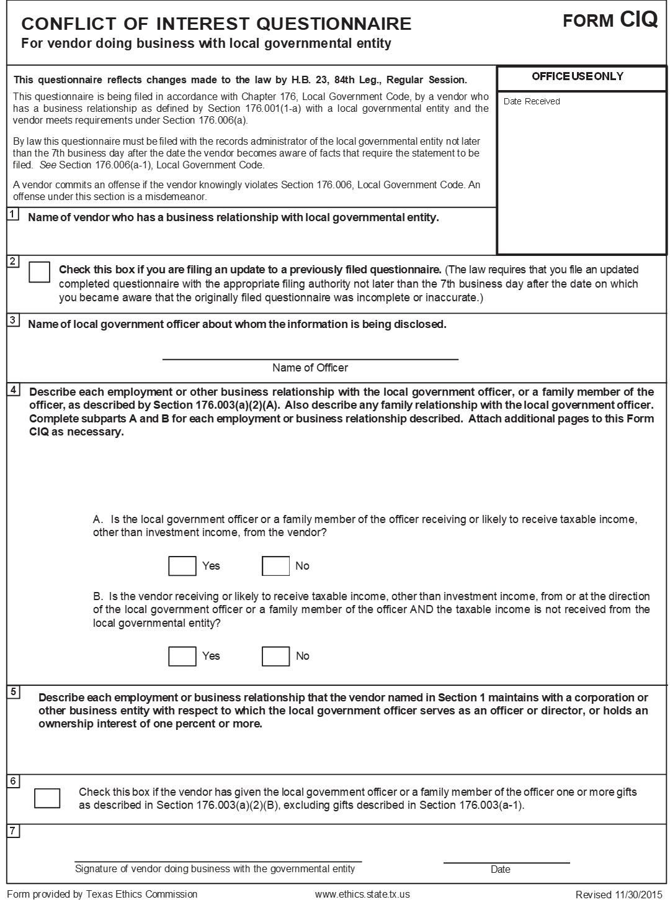

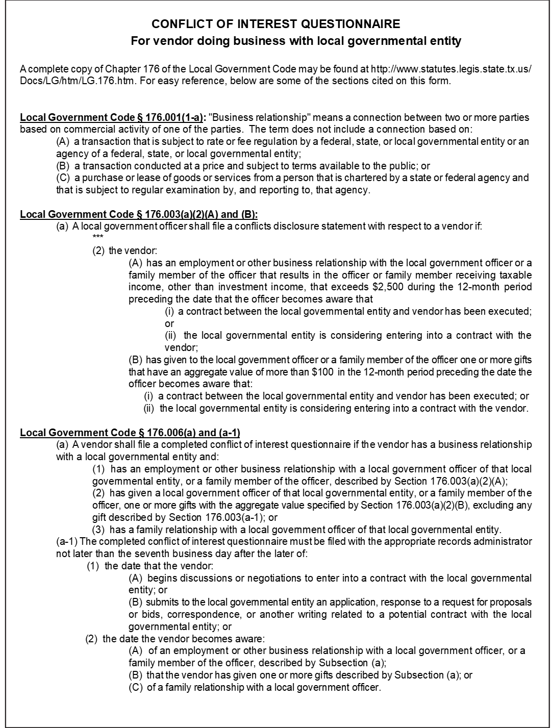

**Administration/Professional Services Rating Sheet**

Grant Recipient Resilient Communities Program (RCP)

Contract No.

Name of Respondent Date of Rating

Evaluator's Name

**Experience** **-- Rate the Respondent of the Request for Proposal (RFP) by awarding points up to the maximum listed for each factor. Information necessary to assess the Respondent on these criteria may be gathered either from past experience with the Respondent and/or by contacting past/current clients of the Respondent.**

**Experience**

|  |  |  |  |  |
| --- | --- | --- | --- | --- |
|  | Factors | Max.Pts. |  | Score |
| 1. | Related Experience / Background with federally funded projects | 10 |  |  |
| 2. | Related Experience / Background with specific project type (housing rehabilitation, acquisition of property, coordination with regulatory agency, etc.) | 5 |  |  |
| 4. | Certified Administrator of Resilient Communities Program (RCP)Program by GLO | 5 |  |  |
| 5. | References from current/past clients | 10 |  |  |
|  | **Subtotal, Experience** | 30 |  |  |

**Work Performance**

|  |  |  |  |  |
| --- | --- | --- | --- | --- |
|  | Factors | Max.Pts. |  | Score |
| 1. | Submits requests to client/GLO in a timely manner | 5 |  |  |
| 2. | Responds to client/GLO requests in a timely manner | 5 |  |  |
| 3. | Past client/GLO projects completed on schedule | 5 |  |  |
| 4. | Work product is consistently of high quality with low level of errors | 5 |  |  |
| 5. | Past client/GLO projects have low level of monitoring findings/concerns | 5 |  |  |
| 6. | Manages projects within budgetary constraints | 5 |  |  |
|  | **Subtotal, Performance** | 30 |  |  |

**Capacity to Perform**

|  |  |  |  |  |
| --- | --- | --- | --- | --- |
|  | Factors | Max.Pts. |  | Score |
| 1. | Qualifications of Professional Administrators / Experience of Staff | 5 |  |  |
| 2. | Present and Projected Workloads | 5 |  |  |
| 3. | Quality of Proposal/Work Plan | 5 |  |  |
| 4. | Demonstrated understanding of scope of the Resilient Communities Program (RCP) Project | 5 |  |  |
|  | **Subtotal, Capacity to Perform** | 20 |  |  |

**Proposed Cost**

|  |  |  |  |  |
| --- | --- | --- | --- | --- |
|  | Factors | Max.Pts. |  | Score |
|  | A = Lowest Proposal $  B = Bidder's Proposal $ |  |  |  |
|  | **A ÷ B X 20 equals Respondent's Score** | 20 |  |  |

**TOTAL SCORE**

|  |  |  |  |  |
| --- | --- | --- | --- | --- |
|  | Factors | Max.Pts. |  | Score |
| 🞎 | Experience | 30 |  |  |
| 🞎 | Work Performance | 30 |  |  |
| 🞎 | Capacity to Perform | 20 |  |  |
| 🞎 | Proposed Cost | 20 |  |  |
|  | **Total Score** | 100 |  |  |